**Phase 5**

**Lesson 3**

**Launch an Instance in a Placement Group**

**Creating the placement group:**

1. Creating a placement group

2. Launching an instance in the placement group

**Step 1:** Creating a placement group

* Click on *Create Placement Group*

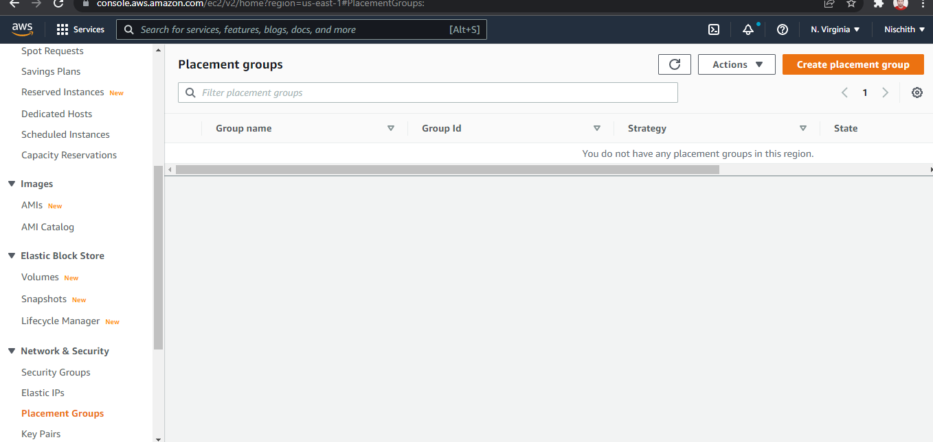

* Provide a name and strategy

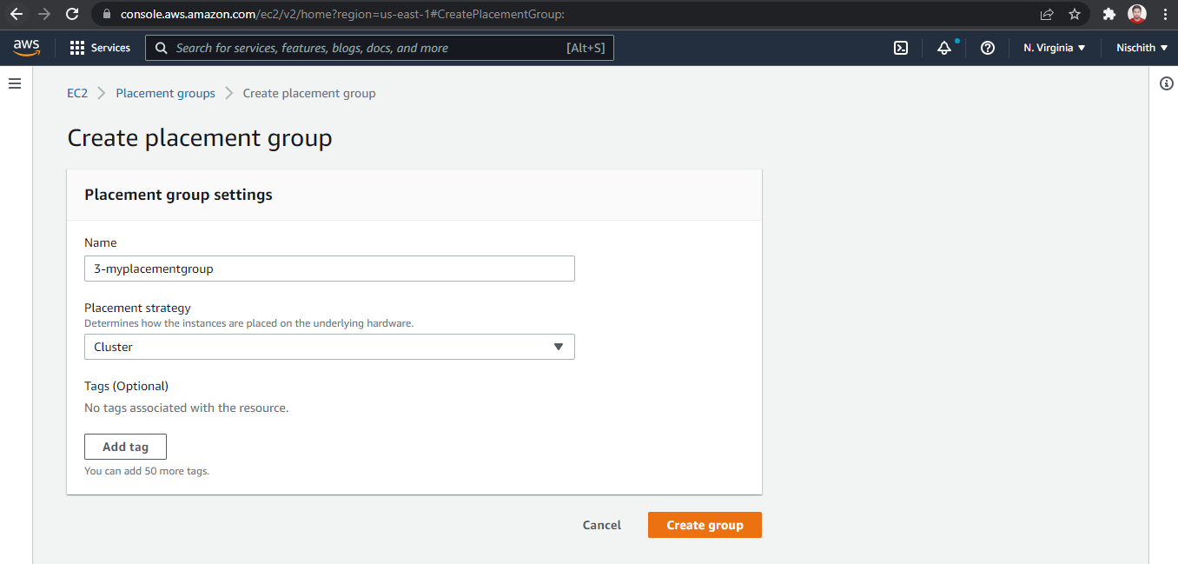

**Step 2:** Launching an instance in the placement group

* Launch the new EC2 instance

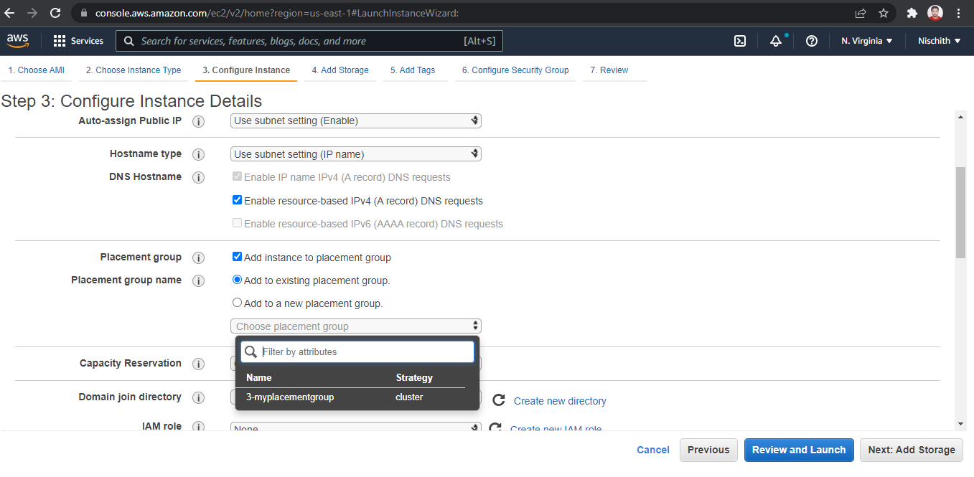

* Select the placement group

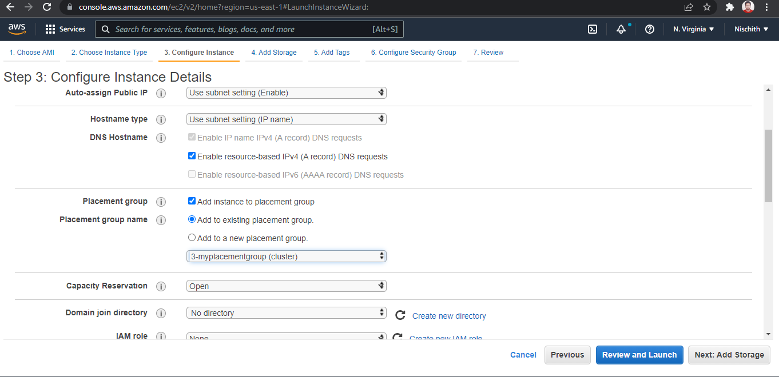

* Verify the placement group of the instance

